**Section 2 – Business Intelligence (Tableau)**

As a Data Analyst of the R&D department of the “Sleeping Clinic” company, you were asked to analyse the health records of the registered company’s users. The Dataset named “***Health and Lifestyle***” contains the anonymized users’ data and their health records (The dataset is attached, also it can be found in the Assessment folder). The dataset consists of 400 rows and 13 columns, covering various sleep-related variables and daily habits. The sleep duration is given in hours, the quality of sleep and the stress level are scaled from 1 to 10, and the physical activity level is given in minutes per day. The blood pressure measurement represents the systolic pressure over diastolic pressure. The other parameters are the person’s ID, gender, age, occupation, BMI, heart rate, daily steps, and type of sleep disorder if it exists.

**Response to the Tasks**

**Stage 1**

The dataset provided for the assignment was transformed by identifying the **“Normal Blood Pressure”** and **“Abnormal Blood Pressure”**. A Search was done on the to identify the blood pressure status. Below is the link where I made my findings and a snapshot update on the dataset after identifying the blood pressure categories.

<https://www.cdc.gov/bloodpressure/about.htm>

Stage 2

Uploading the transform dataset on Tableau for visualization to attempt all the requests in the tasks. Below is the snapshot.

Uploading in progress…………………

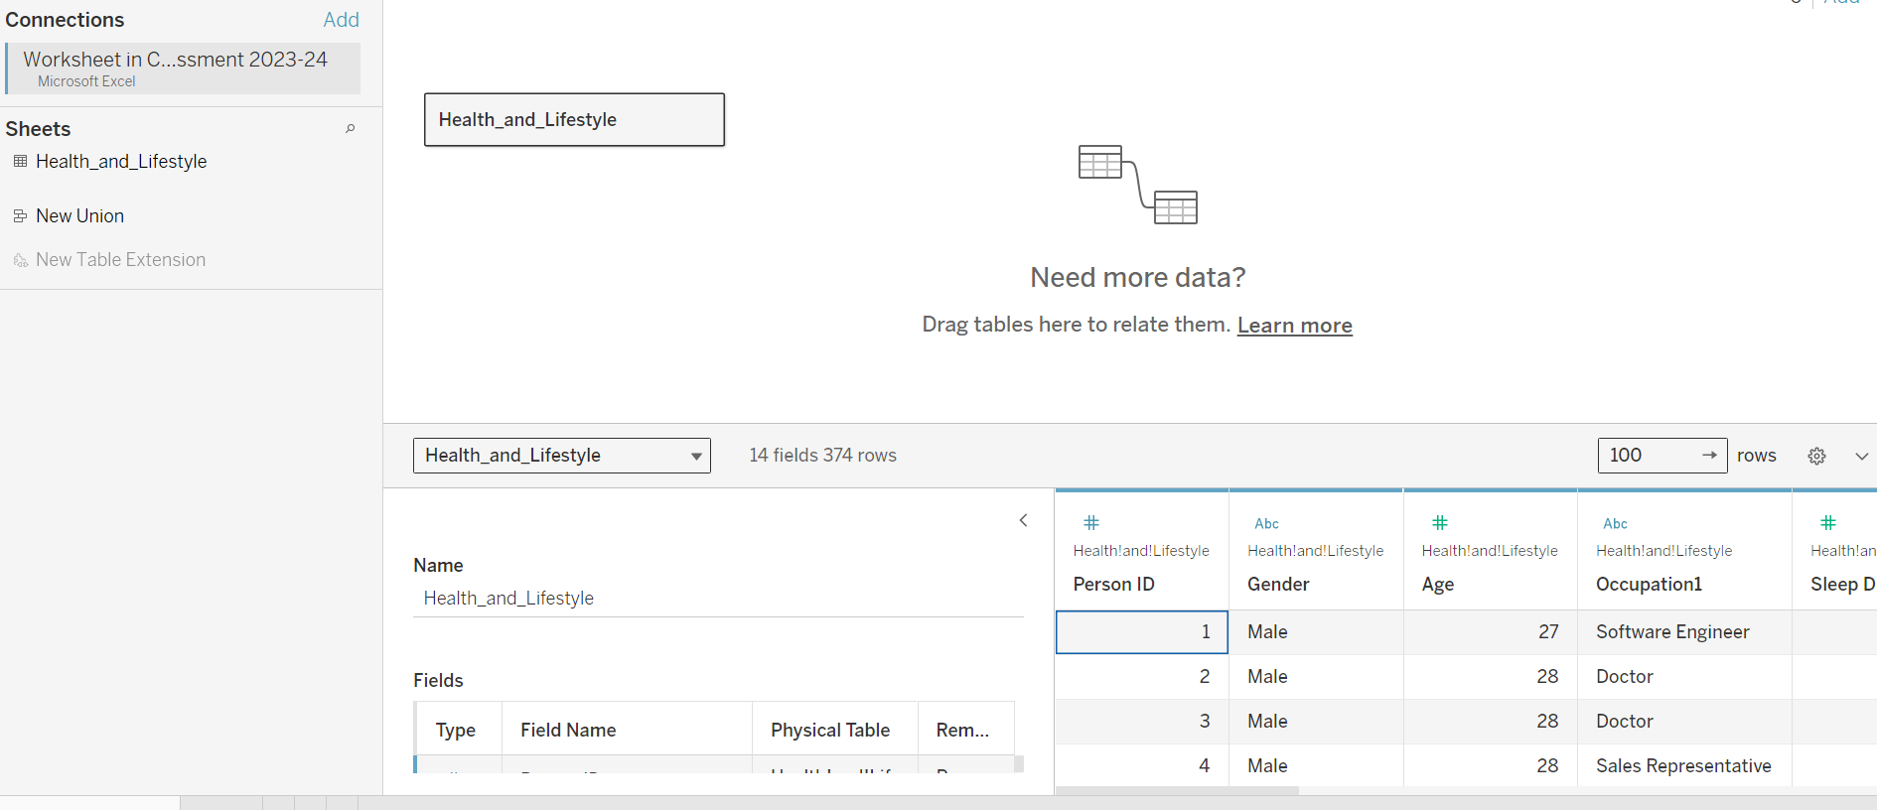

Dataset **“Health_and_Lifestyle”** uploaded successfully.

Stage 3

Visualization on various tasks demanded of me.

**Task 1**: Using the parameter function, display a chart showing the most frequent and less frequent professions with abnormal blood pressure.

**Steps**: Occupation field was dragged from “Table” to “Rows” and the Tab sheet was named Abnormal Blood Pressure see snapshot below.

However, occupation also dragged to Columns and measured as **COUNT** sort from most frequent to less frequent then selected a horizontal bar chart. See snapshot below.

**Task 2:** Using an appropriate chart, display each occupation category's maximum and minimum daily steps. Place the result in descending order.

**Steps:** Occupation field and measure name were dragged from “Table” to “Columns” and the Daily step field with a data type of integer was categories into minimum and maximum in measure value and dragged to “Rows” then selected a horizontal bar chart. Thereafter, the measure name was considered in both filter and colors. See snapshot below for the visual.

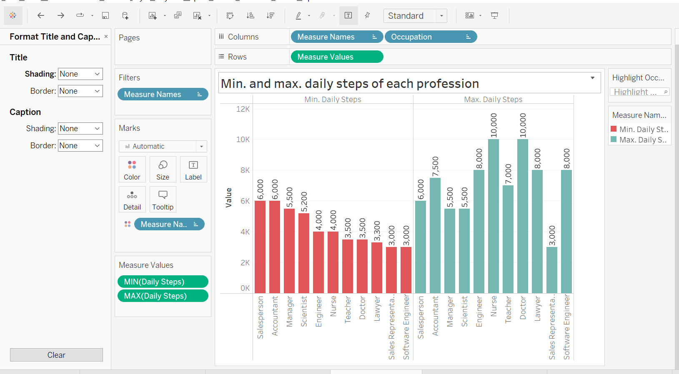

Task 3: Investigate the correlation between BMI, stress level and blood pressure.

Steps: For the investigation using the dataset field which consist of BMI Category, Blood Pressure, Blood Pressure Status, and stress level. BMI Category and Blood Pressure Status field was dragged from “Table” to “Column” then, the stress level was dragged to “Rows” with addition of dimension. thereafter, Gantt view chart was selected, and color was applied BMI Category for better analysis representation. Also, change the shape to shaded triangle.

See snapshot below for the visual.

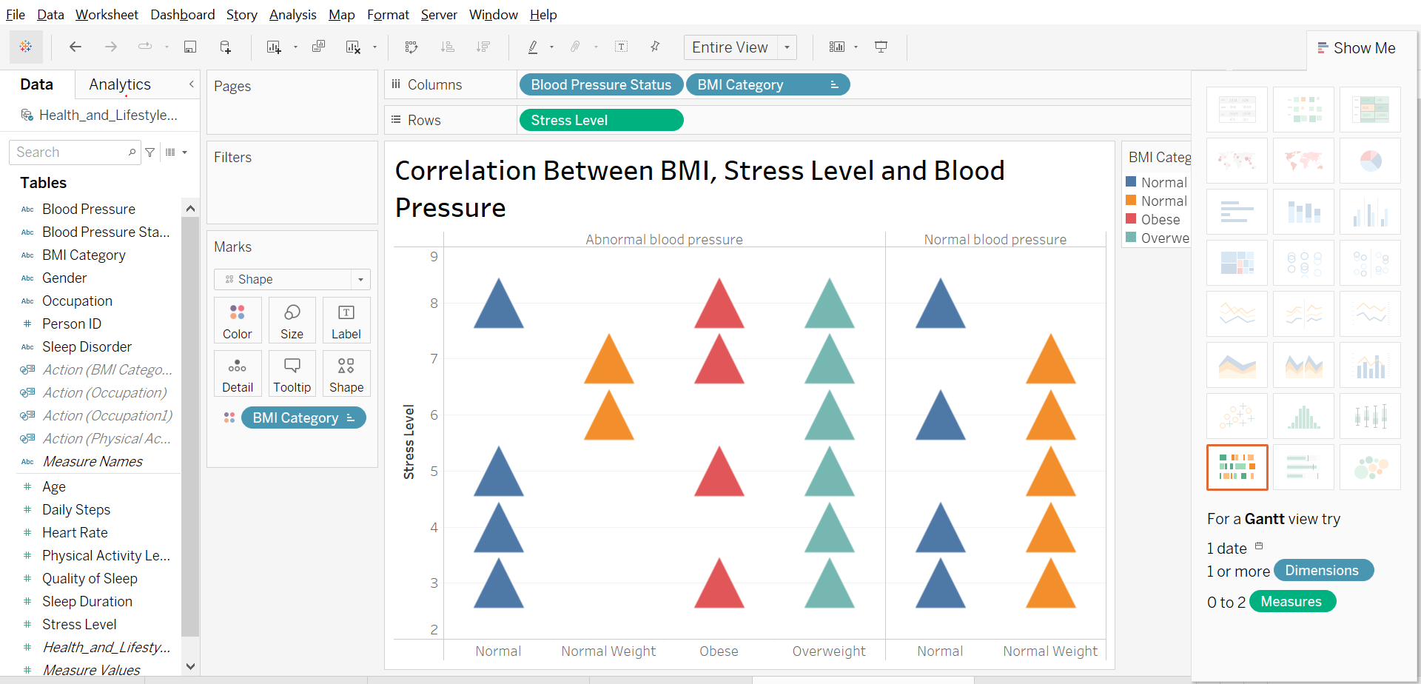

**Investigation**

In the visual the correlation between BMI, Stress level and blood pressure review **overweight BMI** with **abnormal blood pressure** contributed the highest **stress level** of 42% followed by **normal** BMI with **abnormal blood pressure** of 31% **stress level** while the lowest **stress level** contributed 2% are from the **normal weight** body mass index with **abnormal blood pressure.**

**Task 4**: Explore the relationship between physical activity and sleep duration. Demonstrate the connection between both of them and sleep disorders.

Demonstrating the connection between both of **physical activity**, **sleep duration** and **sleep disorders**.

physical activity was represented by dragging to the “columns” space while the sleep duration was moved to “Rows” both on dimensions for better data analysis representation and the sleep disorders was dragged to color for data interpretation. Also, change the shape to shaded diamond.

See snapshots below.

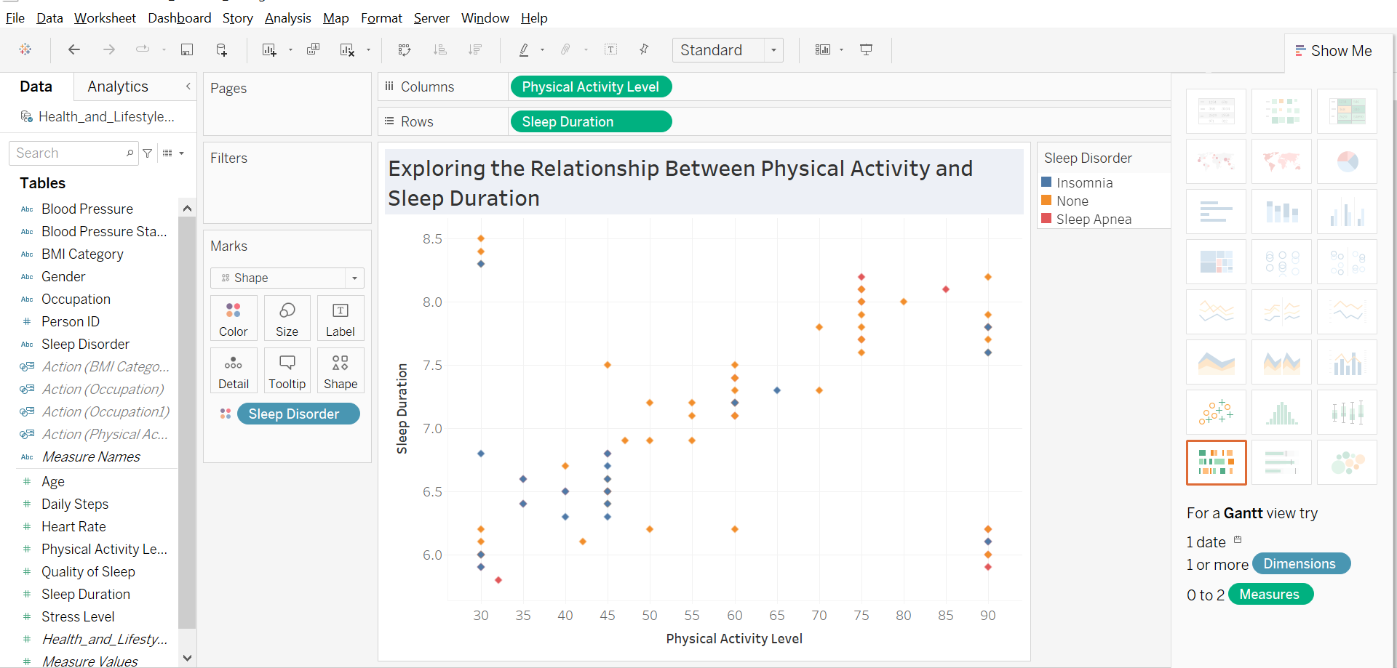

**Task 5:** Create an interactive dashboard with at least four sheets. The interactivity means that if you click on any dashboard sheet, the other sheets should simultaneously display the related information.

To Create an interactive dashboard below are the necessary steps to take.

Step 1: Click on **Dashboard** tabs form the ribbons and select **“New Dashboard”** see snapshot below.

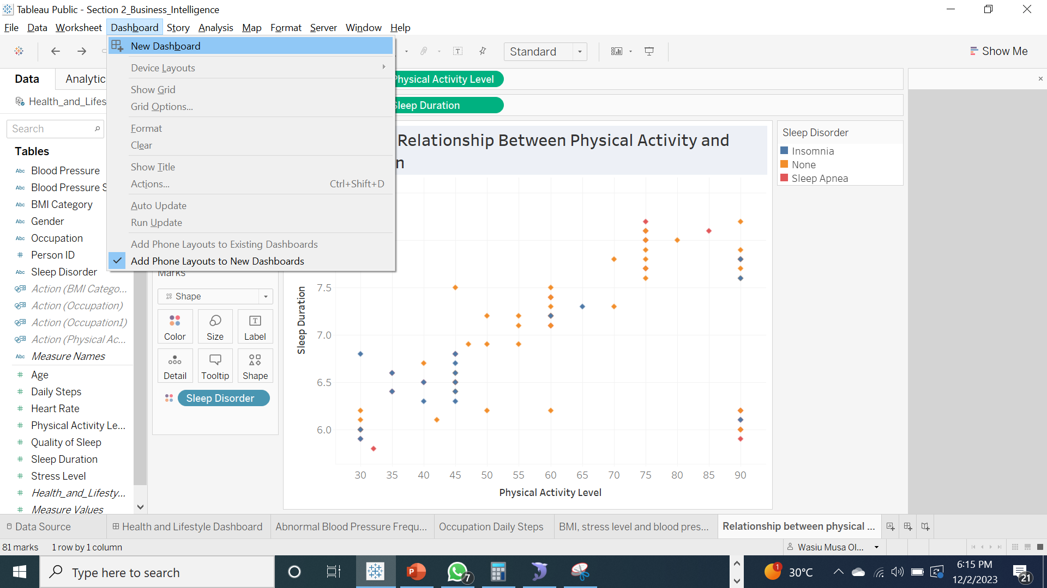

Thereafter below snapshot appears.

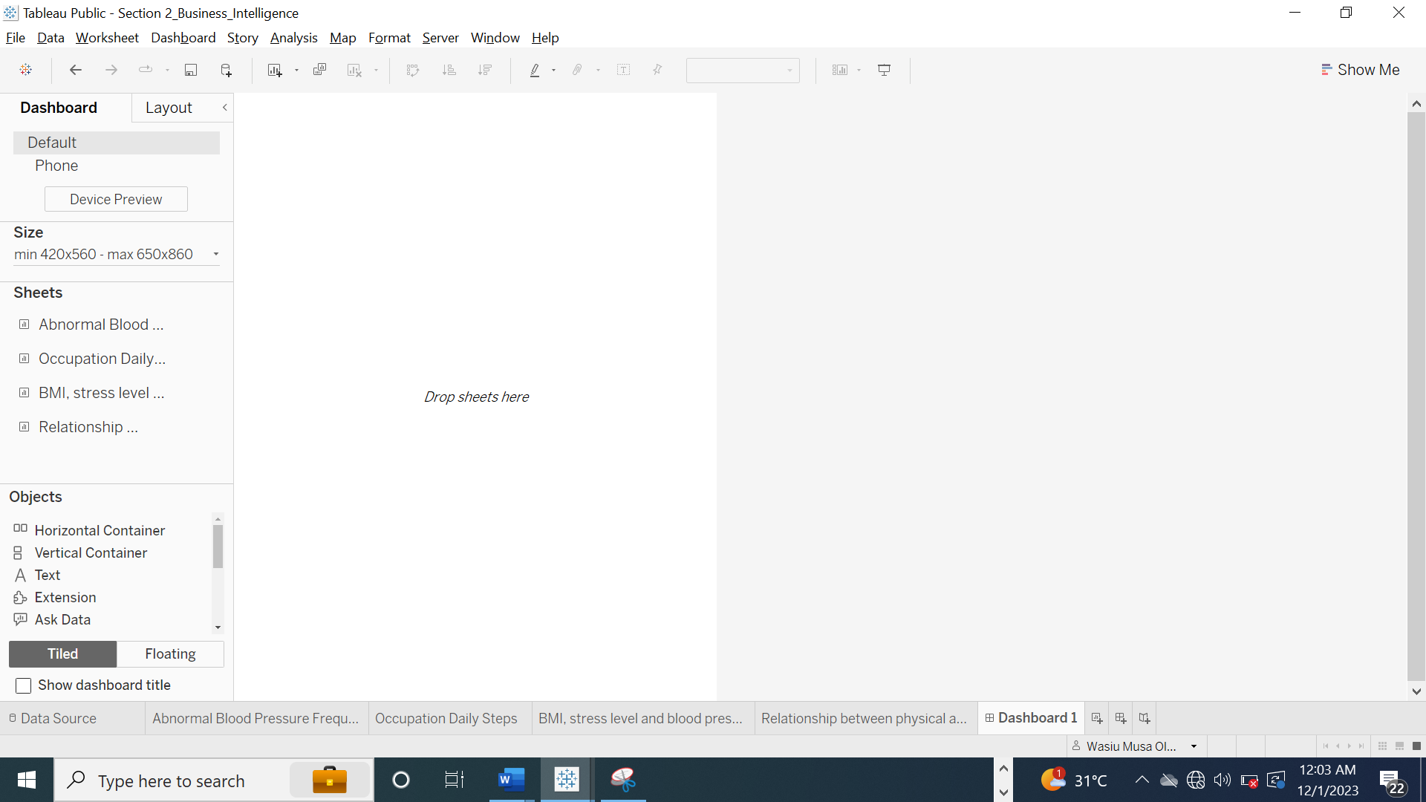

Then, worked on the dashboard layout before assembling the 4 sheets visual for better view on the dashboard. The device preview is set to automatic dashboard size, by clicking on size and select automatic. See below snapshot.

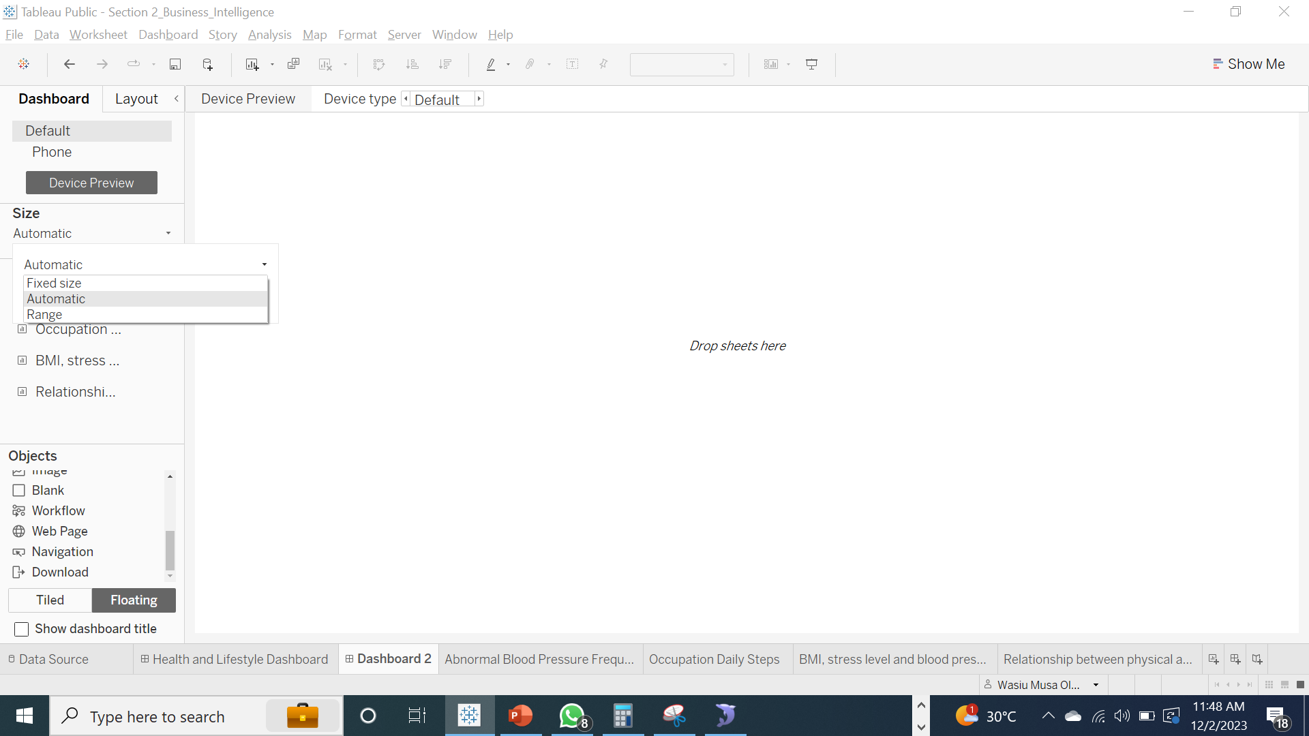

Device preview size

Step 2: The entire tasks sheet results are dragged to the dashboard view and selected the show dashboard title. See snapshot below.

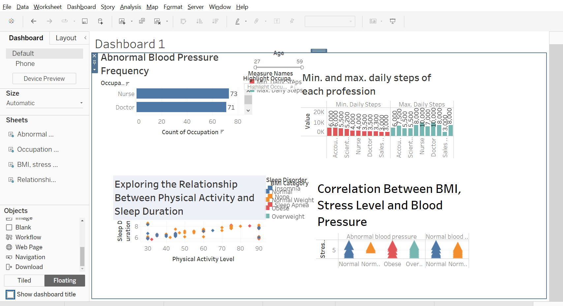

Then, float the four sheets’ visuals and I started rearranging all the visuals to suit and perfect the dashboard view. Also, change the dashboard title by selecting edit title to **“Health and Lifestyle Interactive Dashboard”** and rename the dashboard tab to **“Health and lifestyle Dashboard”.** However, different filters were added such as **occupation, age,** and **gender** to the dashboard to make it more interactive.

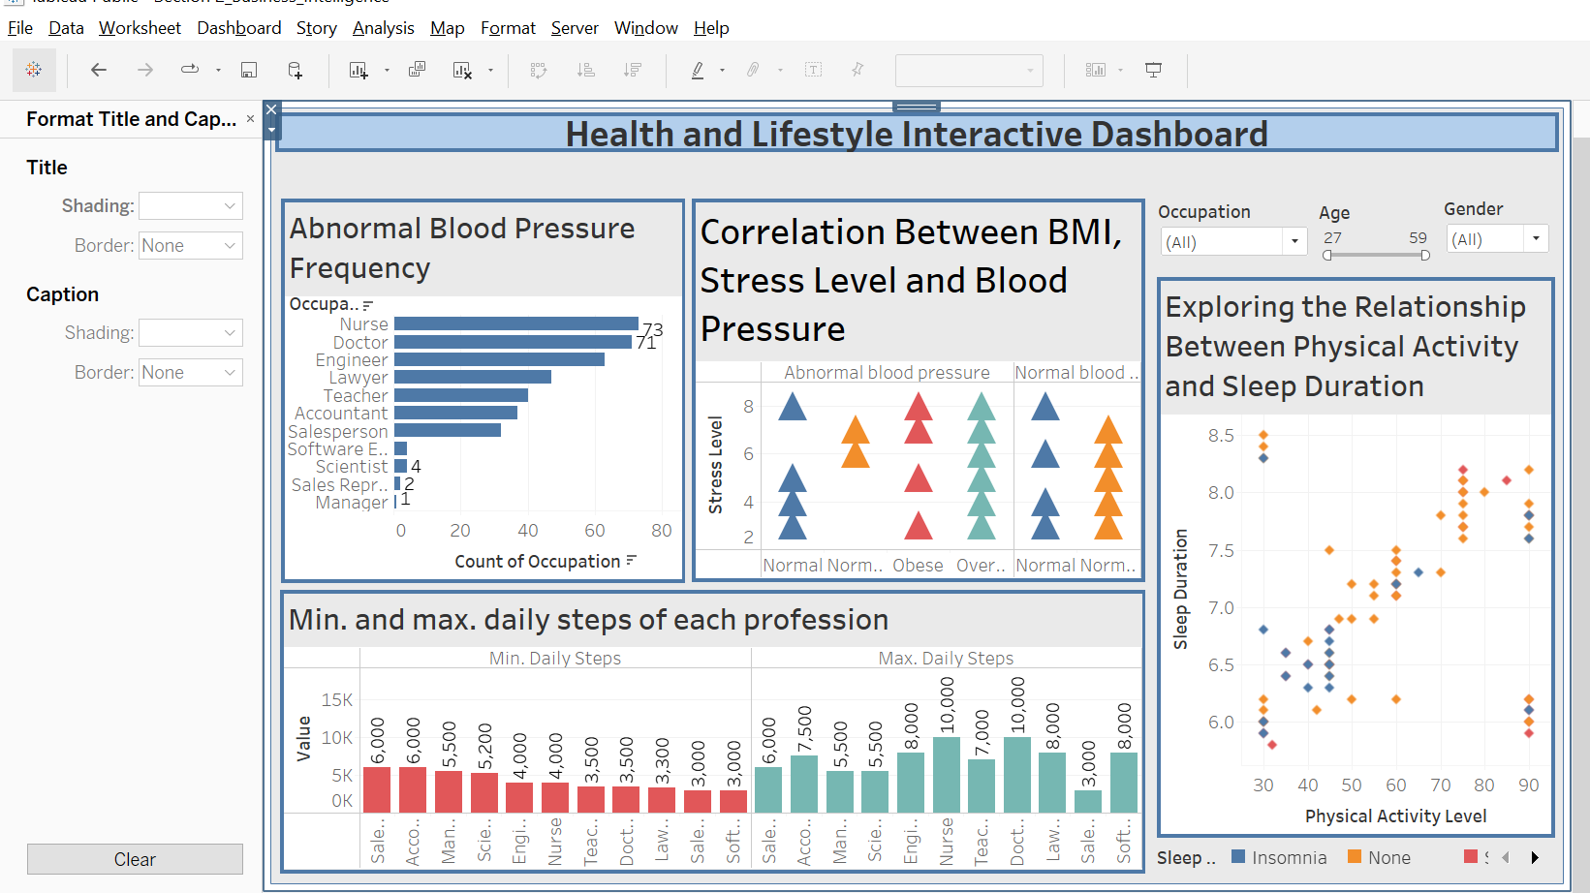

Above snapshot is the final output.

Lastly, creating an interaction among the four sheets on the dashboard if you click on any dashboard sheet, the other sheets should simultaneously display the related information. I simply selected the entire four visuals individually on the dashboard and a filter icon appears by the side then I selected **use as filter** on individual visuals. See below snapshot.

